**SANDEEP S 231901045**

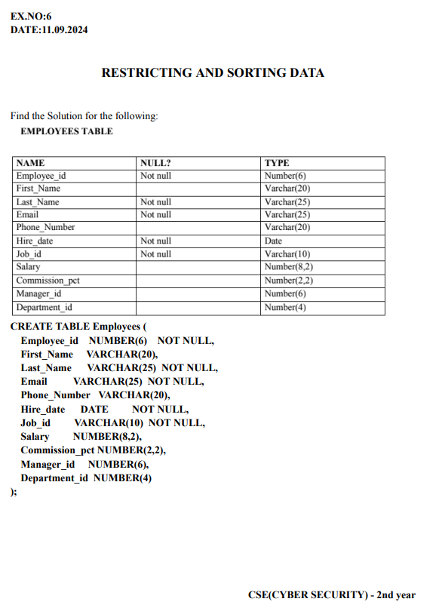

**SANDEEP S 231901045**

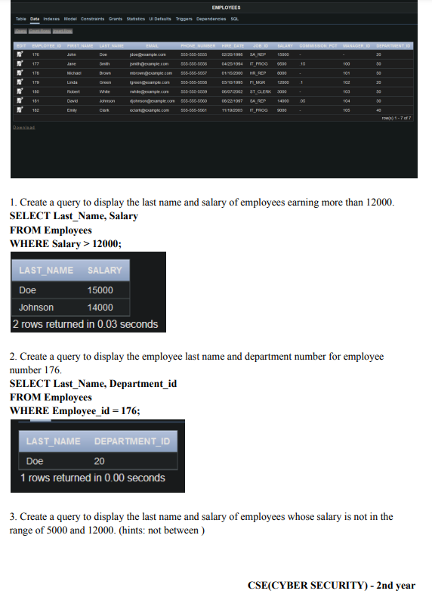

**SANDEEP S 231901045**

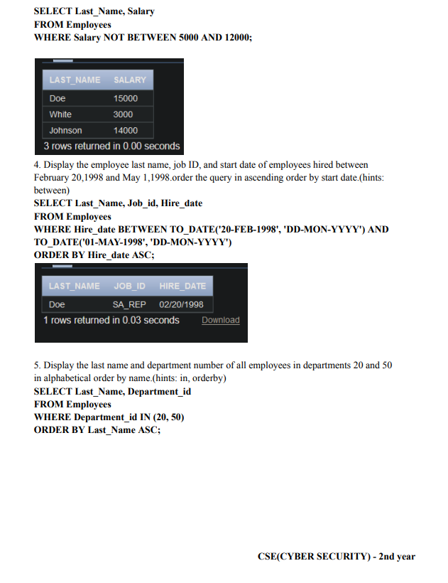

**SANDEEP S 231901045**

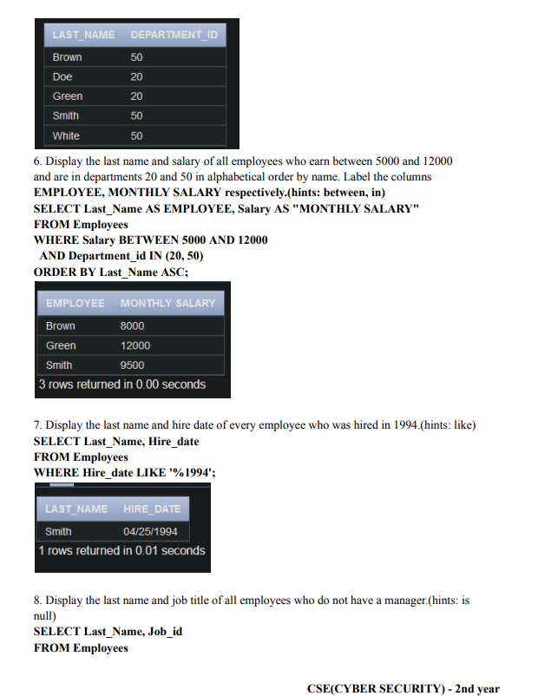

**SANDEEP S 231901045**

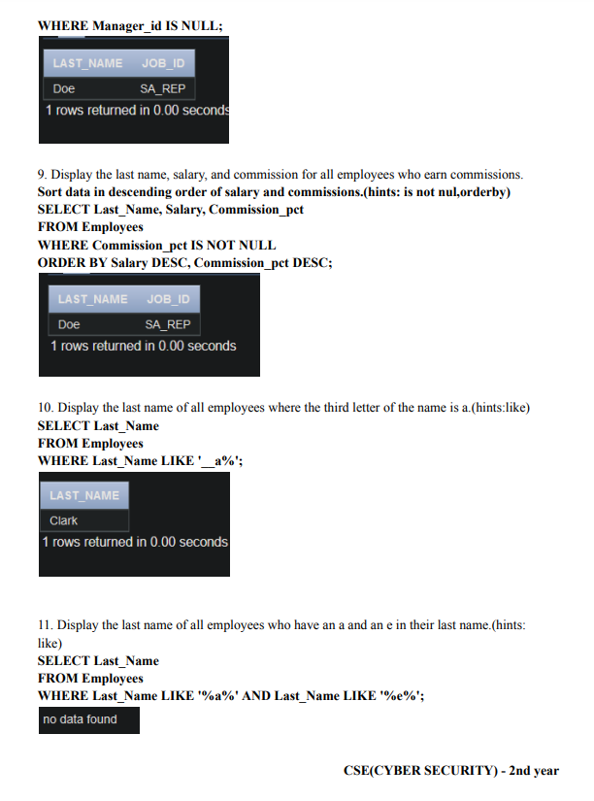

**SANDEEP S 231901045**

